B. Tech Project Report

On

**Enhancing heat transfer using elastic turbulence in concentric rotating cylinders**



Submitted in fulfilment

for the B. Tech Third Year Core

Course on Capstone Project-I (CP302)

by

**Mayank Kumar**

**(2020CHB1045)**

Department of Chemical Engineering

Indian Institute of Technology, Ropar

Ropar, Punjab - 140001

May 2023

**Acknowledgement**

The completion of this project without the aid and supervision of the instructor and teaching assistants would not have been feasible. To start with, I would like to express our deepest gratitude to Dr. Chandi Sasmal for their assistance and guidance. I am able to create this report with the support of constructive criticism and compliments, which also inspired me to continually consider new ideas.

**Abstract**

In this study, we investigate the use of elastic turbulence to enhance the mixed convection heat transfer in concentric rotating cylinders using the open-sourced Computational Fluid Dynamics (CFD) software OpenFOAM. The phenomena, elastic turbulence, is observed for the horizontal concentric inner rotating cylinder configuration, which can arise due to the local stretching of the polymer molecules. This elastic turbulence can enhance mixing and heat transfer in a fluid system, thereby making it an attractive area of research for improving thermal performance.

To explore this approach, we performed a numerical study using OpenFOAM to solve the concerned governing equations, namely, mass, momentum, and energy. We varied various non-dimensional numbers like the Rayleigh number and Weissenberg number at fixed values of Reynolds and Prandtl number value of 1000 and 7 respectively. The results are presented in terms of streamlines and velocity magnitude plots, isotherms and average Nusselt number. Notably, we observe a heat transfer enhancement when the value of Weissenberg number is increased from 0 to 5 at a Rayleigh number value of ${10}^{6}$.

**Contents**

|  |  |  |
| --- | --- | --- |
| **Sr. No** | **Contents** | **Page No.** |
| **01** | **Acknowledgement** | **02** |
| **02** | **Abstract** | **03** |
| **03** | **Problem Description** | **05** |
| **04** | **Governing Equations** | **05** |
| **05** | **Literature Survey** | **07** |
| **06** | **Results and Discussions** | **08** |
| **07** | **Conclusions & Future Plans** | **10** |
| **08** | **References** | **11** |

**Problem Description**

This report focuses on investigating mixed convection heat transfer of viscoelastic fluids within a horizontal concentric annulus with an inner rotating cylinder, also known as Taylor-Couette Flow. The system is characterized by an inner rotating cylinder rotating in counter-clockwise direction with an angular velocity of $Ω$ and an outer stationary cylinder. The surface of the inner cylinder is maintained at a higher temperature of $T_{H}$, whereas, the outer cylinder is kept at a lower temperature of $T_{C}$.

To explore the flow and heat transfer characteristics, we perform detailed numerical simulations using appropriate models and solvers. The simulations will vary the relevant non-dimensional numbers, such as the Rayleigh number and Weissenberg number at fixed values of Reynolds and Prandtl number values of 1000 and 7 respectively.

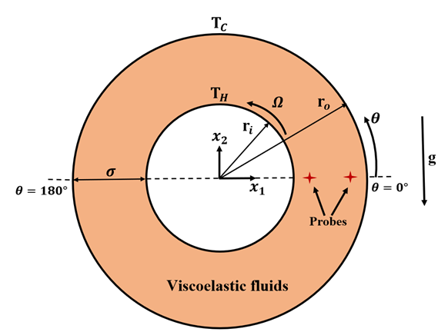

Fig 1: Schematic of the present problem

**Governing Equations**

This study employs a mixed convection heat transfer of viscoelastic fluids in the Taylor-Couette Flow system. The approach is based on the continuity equation, momentum equation, and energy equation, which are the governing equations associated to the present problem. The continuity equation governs the conservation of mass in the system, the momentum equation governs the motion of the fluid, and the energy equation governs the transfer of heat within the fluid. These equations are expressed mathematically as partial differential equations and are solved numerically by discretising the whole computational domain and solving them using appropriate techniques and solvers available in OpenFOAM. The governing equations are written in vector form as follows:

**Continuity Equation:**

$$∇.u=0$$

**Momentum Equation:**

$$ρ\left(\frac{∂u}{∂t}+u.∇u\right)=-∇p+∇.τ+ρgβ_{T}\left(T-T_{ref}\right)e_{2}$$

$$Where,$$

$$τ=τ_{s}+τ_{p}$$

$$τ_{s}=2η_{s}D$$

$$D=\frac{1}{2}(∇u+{\left(∇u\right)}^{T})$$

$$τ_{p}=\frac{η_{p}}{λ}\left(C-I\right)$$

$$C+λC^{*}=I$$

$$Where,$$

$$C^{*}=\frac{∂C}{∂t}+u∇C-C.\left(∇u\right)-\left(∇u^{T}\right).C$$

Note that $C^{*}$ in the above equation denotes the upper-convected derivative of the conformation tensor $C$.

**Energy Equation:**

$$ρC_{p}\left(\frac{∂T}{∂t}+u.∇T\right)=∇.(K∇T)$$

**Boundary Conditions:**

$$At r=r_{i}, u_{θ}=Ωr_{i}, u_{r}=0, T=T_{H}$$

$$At r=r_{o}, u_{θ}=0, u_{r}=0, T=T_{C}$$

Where, $T_{H}>T_{C}$

**Literature Survey**

Before jumping onto the new results, we show some validation with the available literatures. At first, the numerical simulations are carried out using the current software OpenFOAM as available in the published results [1]. The variation of the local Nusselt number distribution at the inner cylinder with respect to the Reynolds number and also the overall Nusselt number for several Rayleigh number are seen to be in a very good agreement (see Figure 2).

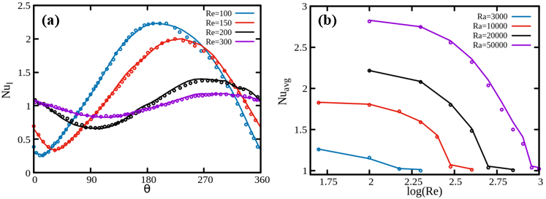

Fig 2: Variation between (a) local Nusselt number distribution at inner cylinder with respect to Reynolds number and (b) Overall Nusselt number for several Rayleigh numbers. The solid lines represent the present results, whereas, the symbols denote the available literature results [1].

Also, we have validated the results of T. H. Kuehn, R. J. Goldstein [3], wherein, the authors have performed both numerical and experimental analysis for natural convection heat transfer in a concentric horizontal configuration. Figure 3 shows that the variation of temperature profiles and local conductivity, which are in line with the literature results.

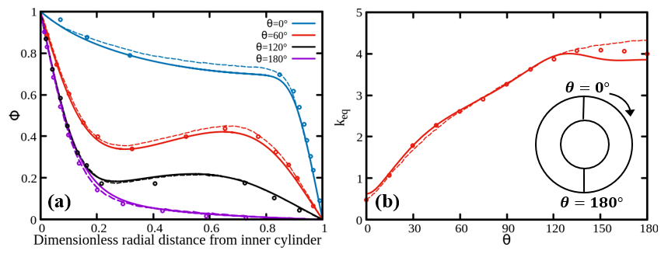

Fig 3: Comparison of experimental and numerical (a) dimensionless radial temperature profiles and (b) local equivalent conductivity of inner cylinder. The solid lines represent the present results, whereas, the symbols and dashed line denote the available experimental and numerical results [3] respectively.

**Results & Discussions**

After performing the validation with the available results, we get the confidence to present new results. So, we have run simulations for various dimensionless numbers, specifically the Reynolds number ($Re)$, Prandtl number ($Pr$), Rayleigh number ($Ra$), and Weissenberg number ($Wi$), while keeping the value of Re fixed at 1000 and $Pr$ at 7. The grid used for the simulations has 60,480 grid elements.

The results shown in Table 1 indicate that for $Ra={10}^{6}$, an increase in the $Wi$ value from $0$ to $5$ leads to a 2.3% enhancement in the Nusselt number. In the context of this study, the Nusselt number expresses the ratio of convective to conductive heat transfer between the inner cylinder and the fluid. However, for $Ra={10}^{3}$, the Nusselt number remains almost the same on increasing the Wi value from $0$ to $5$. This implies that the effect of viscoelasticity on the convective heat transfer rate is not significant for lower Ra values.

Further, the results have been shown in terms of streamlines and velocity magnitude plots as shown in Figure 4. These plots have been drawn using the Tecplot software. From these plots, it is evident that at low values of $Ra={10}^{3}$ the streamlines are smooth and follows the prefect body contour. However, this smoothness is destroyed as the value of *Ra* number increases up to a value of $Ra={10}^{6}$. This is due to the increase in buoyancy force on increasing the value of *Ra*.

Figure 5 shows the isotherms contours. Here, one can clearly see the effect of both *Ra* and *Wi*. At $Ra={10}^{3}$, the buoyancy force is very low and the isotherms suggests that the mode of heat transfer is mainly conductive in nature, irrespective of the value of *Wi.*

However, at $Ra={10}^{6}$, the effect of *Wi* is clearly seen as the isotherms become a bit distorted due to the presence of elastic instability in the system.

Table 1: Average Nusselt Number values at the inner cylinder surface

|  |  |  |  |
| --- | --- | --- | --- |
| **S. No.** | ***Ra*** | ***Wi*** | $$Nu_{avg}$$ |
| 1 | $${10}^{6}$$ | 0 | 2.2896 |
| 2 | $${10}^{6}$$ | 5 | 2.3422 |
| 3 | $${10}^{3}$$ | 0 | 1.4427 |
| 4 | $${10}^{3}$$ | 5 | 1.4427 |

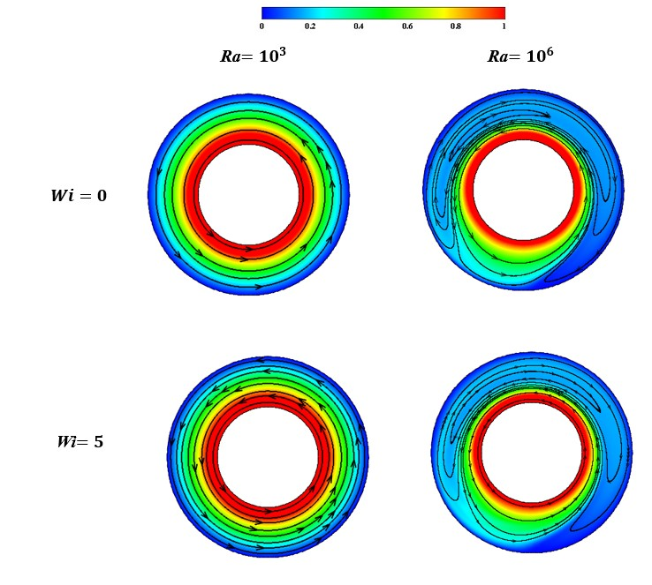

Fig 4: Streamlines and velocity magnitude plots

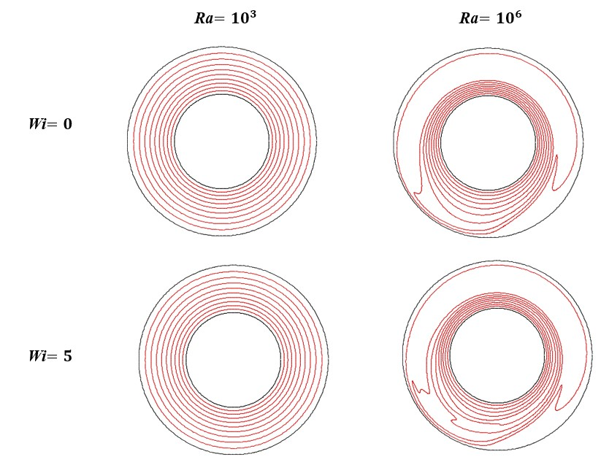

Fig 5: Isotherms

**Conclusions & Future Plans**

The present study provides insights into the convective heat transfer characteristics of viscoelastic fluids in concentric annuli with an inner rotating cylinder. The findings can have implications for the design and optimization of heat transfer systems in industrial applications. So, we have employed the open-sourced CFD package OpenFOAM to perform numerical simulations. The simulations are performed at a fixed Reynolds number of 1000 and Prandtl number of 7. The effect of the dimensionless Weissenberg number is investigated at different Rayleigh numbers. The results show that increasing the Weissenberg number from 0 to 5 at $Ra={10}^{6}$, leads to a heat transfer enhancement of approximately 2.3%. However, no effect on heat transfer rate is observed at $Ra={10}^{3}$.

In future we can increase the value of Weissenberg number to see the corresponding effect on the associated dynamics. Also, the effect of Reynolds number and Prandtl number on the flow and heat transfer dynamics can be studied in detail. Additionally, we change the geometry of the problem by locating the inner cylinder in different configuration (concentric or eccentric).

**References**

1. [**https://www.sciencedirect.com/science/article/pii/S0017931097001415**](https://www.sciencedirect.com/science/article/pii/S0017931097001415)
2. [**https://www.tandfonline.com/doi/abs/10.1080/10407788608913495?journalCode=unht19**](https://www.tandfonline.com/doi/abs/10.1080/10407788608913495?journalCode=unht19)
3. [**https://www.cambridge.org/core/journals/journal-of-fluid-mechanics/article/abs/an-experimental-and-theoretical-study-of-natural-convection-in-the-annulus-between-horizontal-concentric-cylinders/875D6BFAD4999DE4A3D6CDC406CD9DFF**](https://www.cambridge.org/core/journals/journal-of-fluid-mechanics/article/abs/an-experimental-and-theoretical-study-of-natural-convection-in-the-annulus-between-horizontal-concentric-cylinders/875D6BFAD4999DE4A3D6CDC406CD9DFF)
4. [**https://www.sciencedirect.com/science/article/pii/S0735193313000341**](https://www.sciencedirect.com/science/article/pii/S0735193313000341)
5. [**https://www.tandfonline.com/doi/abs/10.1080/01495728408961812**](https://www.tandfonline.com/doi/abs/10.1080/01495728408961812)